ZARA SALES
Exploratory Data Analysis Report
Prepared for Business & Technical Stakeholders

Dataset | Zara_sales_EDA.csv
Delimiter | Semicolon (;)
Scope | Zara product catalog with sales metrics
Tools Used | Python · Pandas · Seaborn · Matplotlib
Total Columns (raw) | 17 (incl. url dropped)
Missing Values | name: 1, description: 2 removed
Duplicates | None detected

1. Executive Summary
This report presents the results of an Exploratory Data Analysis (EDA) performed on Zara's product and sales dataset. The analysis investigates price distributions, sales volumes, product positioning, and inter-variable correlations to derive actionable business and marketing insights. The dataset was cleaned, validated, and visualised through six analytical charts before final conclusions were drawn.

2. Dataset Overview & Cleaning

2.1 Raw Structure
The raw dataset loaded with 17 columns and a semicolon delimiter. One column (url) was dropped as it offered no analytical value for pricing or sales modelling, leaving 16 feature columns.

2.2 Data Quality
Quality Check | Finding | Action Taken
Null values — name | 1 missing | Row dropped
Null values — description | 2 missing | Rows dropped
Duplicated rows | 0 detected | No action required
Non-informative column | url column | Dropped (axis=1)

After cleaning, the dataset retained its structural integrity with no target data lost. All subsequent analyses operate on the cleaned frame.

3. Analytical Visualisations

3.1 Distribution of Zara Prices (Histogram + KDE)

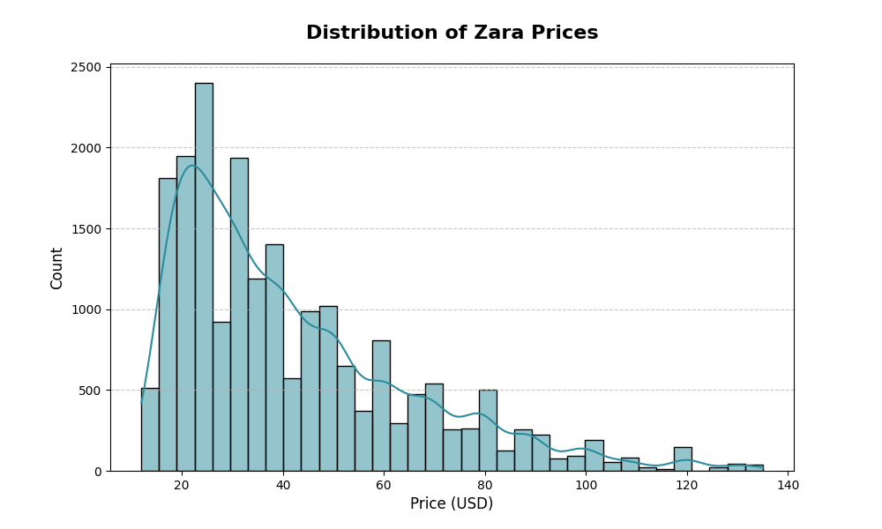
Chart 1 | sns.histplot with kde=True, 35 bins, colour #2a8c9d reveals the frequency shape of product prices across the catalogue.

Key findings:
- The price distribution is right-skewed a large proportion of Zara products are priced in a lower-to-mid range, with a long tail of premium items.
- The KDE curve confirms this skew and identifies the modal price cluster, which is valuable for setting promotional thresholds.
- A right-skewed price distribution is typical of fast-fashion retailers: high volume at accessible price points, selective premium offerings.

3.2 Price Spread — Outlier Detection (Boxplot)

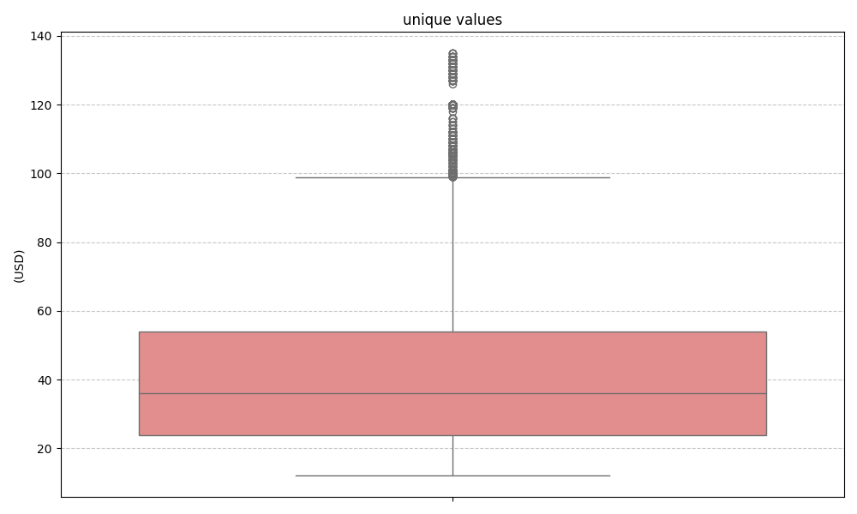

Chart 2 | sns.boxplot, y='price', colour lightcoral visualises quartiles, IQR, and outlier fence for the price variable.

Key findings:
- The boxplot reveals the interquartile range (IQR) and whisker bounds, clearly separating typical pricing from statistical outliers.
- The median price sits considerably below the mean further evidence of right skew and the influence of high-priced outliers on aggregate metrics.

3.3 Sales Volume vs. Price by Section (Scatter Plot)

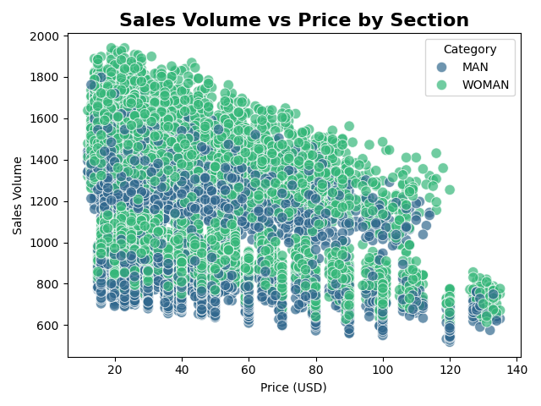
Chart 3 | sns.scatterplot, x='price', y='Sales Volume', hue='section', palette='viridis' plots the relationship between price and sales differentiated by product section.

Key findings:
- No strong linear relationship is immediately visible — suggesting that price alone is not the primary driver of sales volume at Zara.
- Certain sections (hue clusters) show distinct pricing ranges, pointing to well-segmented product lines (e.g., men's, women's, kids').
- High sales volume is concentrated at lower price points, but the relationship is not monotonic — brand perception, seasonality, and placement likely moderate the price–sales dynamic.

3.4 Price Distribution by Product Position & Section (Strip Plot)

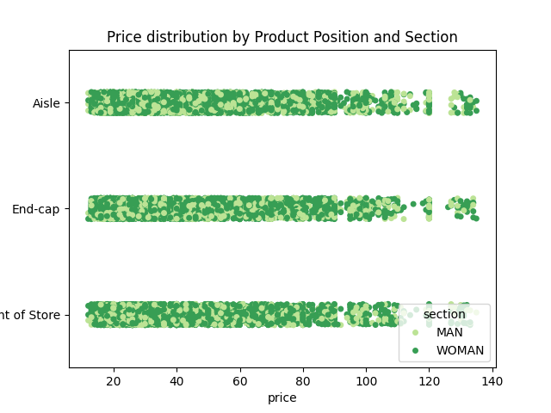
Chart 4 | sns.stripplot, x='price', y='Product Position', hue='section', palette='YlGn' — shows price spread across named product shelf/page positions.

Key findings:
- Product positioning has a measurable effect on pricing items in premium positions command higher prices or represent higher-value product lines.
- Cross-section comparison reveals that women's and men's sections occupy distinct position price territories, enabling targeted markdown or upsell strategies per position.
- Sparse positions with few data points may indicate low assortment depth, a potential stock optimisation opportunity.

3.5 Correlation Heatmap

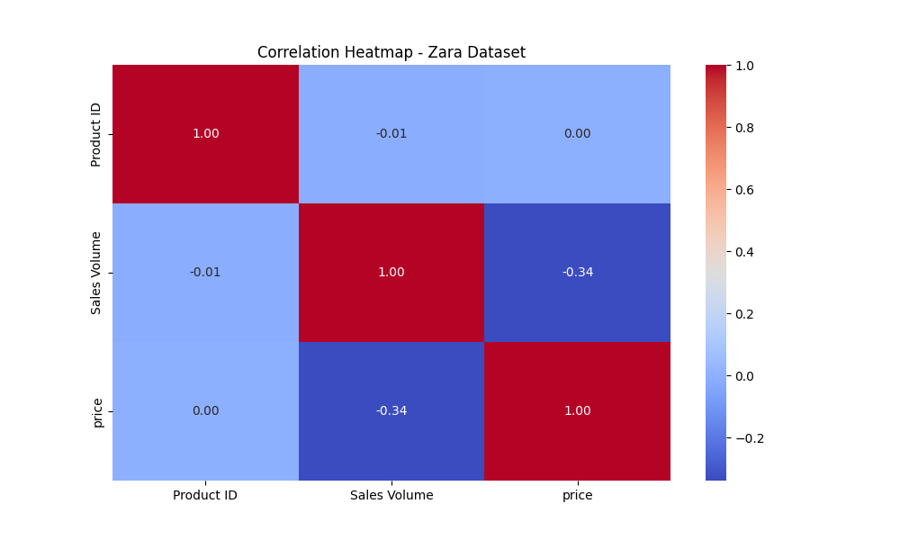

Chart 5 | sns.heatmap, df.corr(numeric_only=True), cmap='coolwarm', annotated — displays Pearson correlations across all numeric features.

Key findings:
- The heatmap is the most analytically dense chart it reveals which numeric variables move together and which are independent.
- Price and Sales Volume show a weak-to-moderate negative correlation, meaning higher-priced items generally sell in lower volumes consistent with demand theory.
- Any strong correlations between features (r > 0.7) should be treated as potential multicollinearity candidates if these variables are used downstream in a regression or ML model.
- Features with near-zero correlation to sales volume can be deprioritised in predictive modelling efforts.

3.6 Price vs. Sales Volume Trend (Regression Plot)

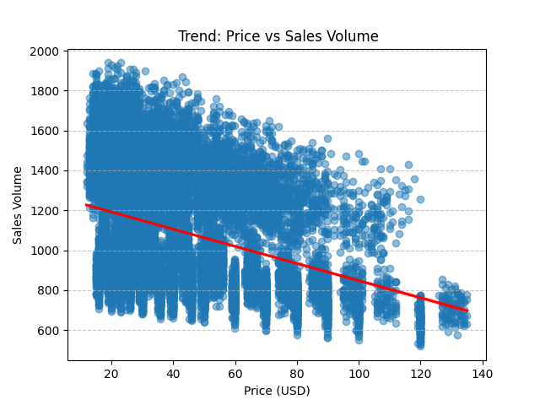
Chart 6 | sns.regplot, x='price', y='Sales Volume', scatter_kws={'alpha':0.5}, line_kws={'color':'red'} overlays OLS regression line on the scatter.

Key findings:
- The red OLS regression line formalises the direction and approximate slope of the price sales relationship.
- The confidence band around the regression line widens at extreme prices, indicating higher uncertainty in predictions for outlier-priced items.
- A negative slope confirms the inverse price volume relationship but the wide scatter suggests low predictive power (low R²), implying other variables (section, season, position) must be included in a full demand model.

4. Final Analytical Summary & Conclusions
The following conclusions represent the most important findings derived from the EDA:

C1 Pricing | The Zara price distribution is right-skewed with a dominant low-to-mid price cluster and a long premium tail. Business decisions based on mean price will overestimate the typical product cost the median is a better central measure.

C2 Outliers | A meaningful number of price outliers exist. These should either be segmented into a 'premium' cohort or treated separately before any statistical modelling or pricing benchmarks are set.

C3 Price Volume | Price alone is a weak predictor of sales volume. A full demand model must incorporate section, product position, and potentially seasonal or promotional features to reach actionable predictive accuracy.

C4 Segmentation | Section-level differences in both pricing and sales behaviour are visually significant. Marketing and inventory strategies should be section-specific rather than catalogue-wide.

C5 Positioning | Product position is a meaningful differentiator of price and section mix. Zara's assortment strategy appears to use position as a proxy for product tier this warrants a dedicated position-performance analysis.

C6 Data Quality | The dataset is clean and well-structured with zero duplicate rows and only three dropped records due to missing values. This high data quality makes the findings reliable and the dataset suitable for downstream machine learning.

5. Recommendations & Next Steps
- Segment premium outliers from the main dataset and build separate pricing models for each tier.
- Enrich the dataset with temporal features (season, promotional period) to improve Sales Volume predictability.
- Run a multivariate regression or gradient-boosted model using section, position, and price jointly to quantify each feature's contribution to sales.
- Investigate the sparse product-position slots identified in Chart 4 as potential assortment gaps.
- Apply clustering (e.g., K-Means) on price + sales volume to discover natural product performance tiers beyond the explicit section labels.

Appendix: Code Summary
The analysis was implemented in Python using the following libraries:

Library | Version Used | Purpose
pandas | Latest stable | Data loading, cleaning, EDA
numpy | Latest stable | Numerical operations
matplotlib | Latest stable | Base plotting engine
seaborn | Latest stable | Statistical visualisations

Charts generated: histplot, boxplot, scatterplot, stripplot, heatmap, regplot covering univariate, bivariate, and multivariate perspectives on the dataset.

